Micro- and Nanoplastics: Crossing the Blood-Brain Barrier to Drive Sustained Neuroinflammation and HPA Axis Dysregulation

Tran Quoc Hoang
School of Biotechnology, International University - Vietnam National University HCM City
Student ID: BTBTWE24036
Immunology (BT335IU)
Assoc. Prof. Hoai T. T. Nguyen
31/10/2025

Author Note
The abstract was drafted with the assistance of an AI language model and subsequently reviewed, fact-checked, and revised by the author. All other sections of the paper were written independently by the author.
The Quarto source code for this paper is available at https://github.com/ht2905/TranQuocHoang_IM25_Newsletter.
Correspondence concerning this article should be addressed to Tran Quoc Hoang, School of Biotechnology, International University - Vietnam National University HCM City, Quarter 33, Linh Xuan Ward, Ho Chi Minh City 71309, Vietnam, Email: BTBTWE24036@student.hcmiu.edu.vn

Abstract
The ubiquitous presence of micro- and nanoplastics (MNPs) constitutes a growing global environmental and health crisis. This paper explores the alarming neurotoxic potential of MNPs by dissecting their mechanisms of action within the central nervous system (CNS). Nanoplastics, due to their diminutive size, facilitate entry into the body via ingestion and inhalation, and are capable of traversing the Blood-Brain Barrier (BBB) through pathways like endocytosis and the ‘Trojan Horse effect.’ Once within the brain, non-degradable MNPs trigger a sustained state of neuroinflammation via persistent microglial activation. This process is amplified by frustrated phagocytosis and subsequent activation of the NLRP3 Inflammasome, leading to the release of potent pro-inflammatory cytokines. Furthermore, MNP exposure in peripheral sites, mediated by the Gut-Brain Axis (GBA), drives systemic inflammation—which in turn leads to functional consequences like HPA axis dysregulation, anxiety-like behaviors, and cognitive deficits. The evidence establishes MNPs as significant neurotoxic agents, necessitating urgent, globally coordinated prevention and the development of targeted therapeutics, such as BBB-permeable NLRP3 inhibitors.
Keywords: Microplastic, Microparticles, Nanoplastic, Nanoparticles, Neuroinflammation, Microglia, Environmental Pollution

Tóm Tắt
Sự hiện diện phổ biến của vi và hạt nhựa nano (MNPs) là một cuộc khủng hoảng môi trường và sức khỏe toàn cầu ngày càng gia tăng. Bài báo này khám phá tiềm năng độc thần kinh đáng báo động của MNPs bằng cách phân tích cơ chế hoạt động của chúng trong hệ thần kinh trung ương (CNS). Nhựa nano, nhờ kích thước nhỏ bé, dễ dàng xâm nhập vào cơ thể qua đường tiêu hóa và hô hấp, và có khả năng đi qua Hàng rào máu-não (BBB) thông qua các con đường như nhập bào (endocytosis) và hiệu ứng "Ngựa thành Troia" (Trojan Horse). Khi đã vào não, các hạt nhựa nano không phân hủy kích hoạt trạng thái viêm thần kinh kéo dài thông qua sự kích hoạt liên tục của tế bào thần kinh đệm nhỏ (microglia). Quá trình này được tăng cường bởi thực bào thất bại (frustrated phagocytosis) và sự kích hoạt phức hợp NLRP3 Inflammasome, giải phóng các cytokine gây viêm mạnh. Hơn nữa, sự phơi nhiễm MNPs ở các vị trí ngoại vi, thông qua Trục ruột-não (GBA), thúc đẩy tình trạng viêm toàn thân, dẫn đến các hậu quả chức năng như rối loạn trục HPA, các hành vi giống như lo âu và suy giảm nhận thức. Bằng chứng cho thấy MNPs là tác nhân độc thần kinh quan trọng, đòi hỏi phải có các biện pháp phòng ngừa khẩn cấp, phối hợp trên toàn cầu và phát triển các liệu pháp điều trị nhắm mục tiêu, chẳng hạn như chất ức chế NLRP3 có thể xuyên qua BBB.
Keywords: Microplastic, Microparticles, Nanoplastic, Nanoparticles, Neuroinflammation, Microglia, Environmental Pollution

Micro- and Nanoplastics: Crossing the Blood-Brain Barrier to Drive Sustained Neuroinflammation and HPA Axis Dysregulation

Introduction
The ubiquitous presence of microplastics (MPs) and nanoplastics (NPs) is a defining global environmental crisis of the 21st century. First named by (Thompson et al., 2004), microplastics are defined as particles with diameters from $\text{1} μ\text{m}$ to $\text{5} \text{mm}$, while nanoplastics have diameters smaller than $\text{1} μ\text{m}$. Given their non-degradable nature and ability to carry adsorbed toxicants, MNPs represent a significant form of environmental pollution whose full impact is only beginning to be understood.
The mechanism driving this systemic harm is centered around the Gut-Brain-Axis (GBA). This axis represents the bidirectional communication pathway linking the nervous system and the immune system, thereby coordinating the body’s response to both internal and external stressors. It is also through this pathway that environmental insults can translate into central nervous system (CNS) dysfunction. This paper argues that MNPs exposure poses an alarming neurological risk by facilitating the particles’ access to the brain, either directly or indirectly. Once in the CNS, these particles can trigger a sustained, non-resolving state of neuroinflammation via persistent microglial activation—ultimately resulting in cognitive and behavioral deficits.

MP Transport and Crossing the Blood-Brain Barrier (BBB)

Routes of Entry
MNPs enter the body via several primary routes. The most prevalent pathways are ingestion—mainly from contaminated food and drinking water—and inhalation—often from airborne particles such as indoor dust and synthetic clothing fibers. While dermal absorption remains a possibility, it is generally considered a less significant route. Figure 1 the translocation pathway of MNP to the brain. Recent research discovered that nanoplastics appear to be the most dangerous type, as their diminutive size facilitates rapid entrance into the bloodstream and distribution throughout the body (Kopatz et al., 2023).

Figure 1
Environmental Sources and MNPs’ Pathways to the Brain
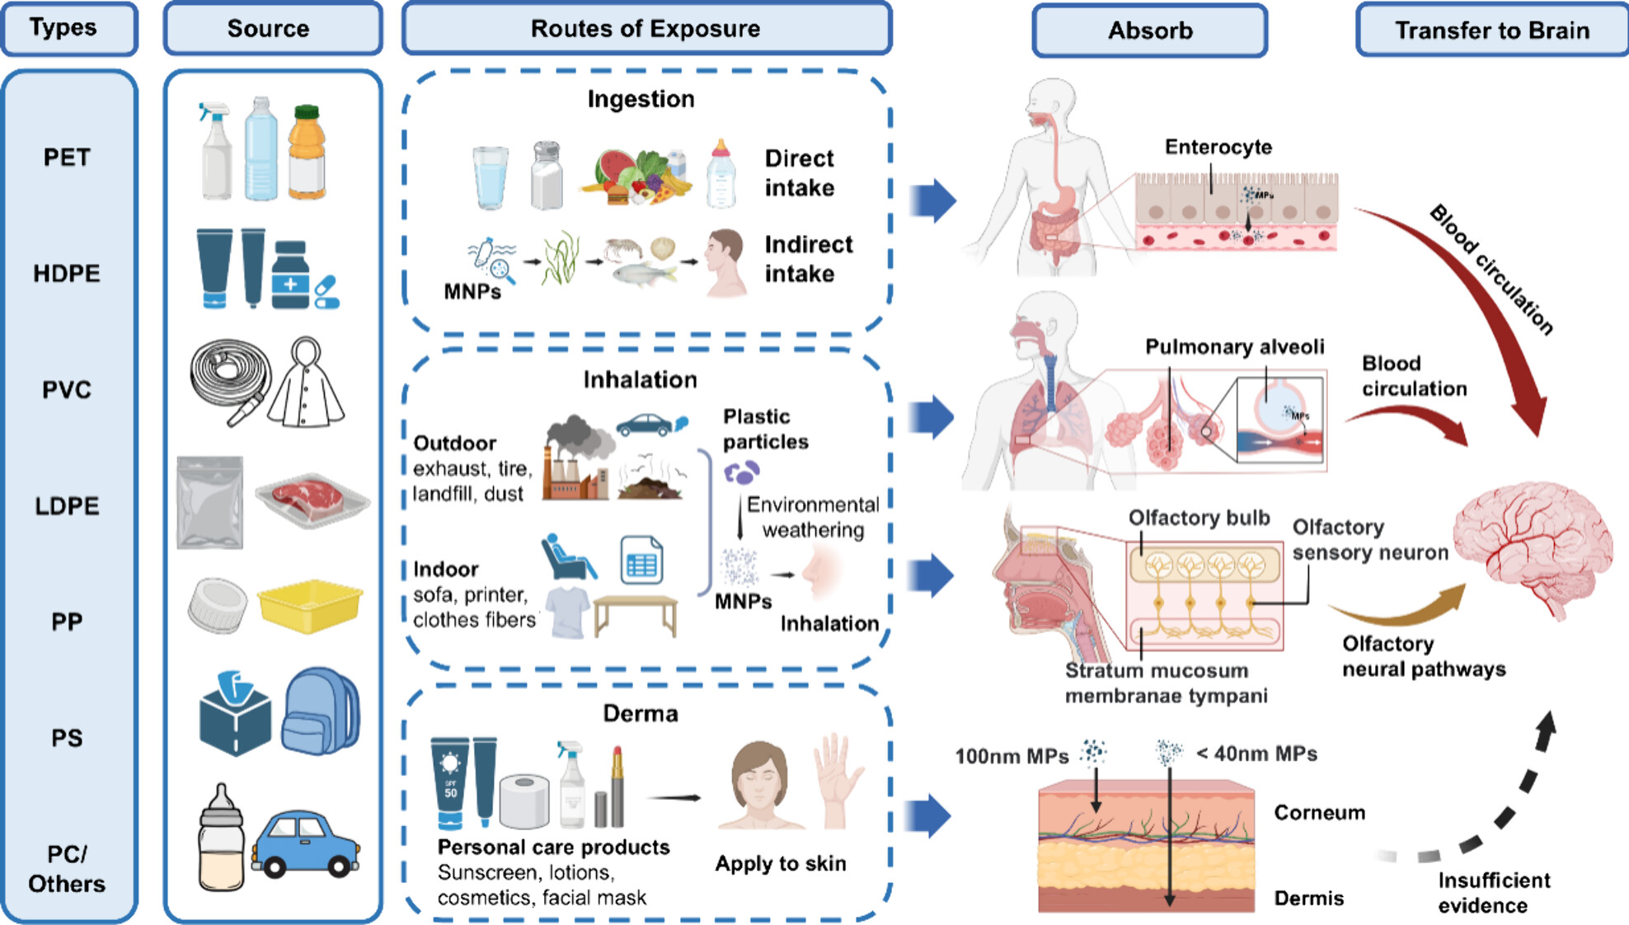
Note. This diagram showcases the types of plastics, where they come from, and how they enter the body. The American Plastics Industry Association created the SPI code (SPI-Code) to provide a standard method for classifying plastics. Nanoplastics are best at traversing through the BBB into the brain due to their diminutive size. Reprinted from Ma, Q., Lei, J., Pang, Y., Shen, Y., & Zhang, T. (2025). Neurotoxicity of Micro- and Nanoplastics: A Comprehensive Review of Central Nervous System Impacts. Environment & Health. https://doi.org/10.1021/envhealth.5c00087.

Blood-Brain Barrier Structure
The CNS has a sophisticated shield called the Blood-Brain Barrier (BBB) that separates brain matter from the rest of the body. This structure is formed by specialized cerebral endothelial cells connected by tight junctions, along with pericytes and astrocytes (McConnell & Mishra, 2022). The BBB effectively limits the passage of foreign substances, pathogens, and large molecules from the circulatory system into the brain, which helps maintain the neural microenvironment’s homeostasis.

Translocation Hypotheses
There are many hypotheses regarding the MNPs’ route through the BBB. One such route is paracellular diffusion, which in theory could allow even smallest nanoplastic particles to pass, although this pathway is heavily restricted (Campbell et al., 2012; Winiarska et al., 2024). A more probable mechanism is endocytosis—where NPs are internalized by the brain endothelial cells and subsequently exocytosed into the brain interstitial fluid (Hamed et al., 2022). A third, highly discussed hypothesis is the “Trojan Horse effect”. This scenario presumes that MNPs are first phagocytized by circulating immune cells, which then act as vectors to carry them across the BBB (Li et al., 2025).

Associated Toxicants
A critical factor that exacerbates MNP-related neurotoxicity is associated toxicants. MNPs, due to their high surface-to-volume ratio, readily absorb chemical additives and environmental pollutants, (e.g., benzo[a]pyrene, okadaic acid) (Yan et al., 2023). These chemicals also have the capability to disrupt the BBB and impair tight junction integrity, thereby allowing the plastic particles easier access to the brain tissue and synergizing the overall neurotoxic effect. (Cheng et al., 2023)

Microglial Activation and Neuroinflammation

The Role of Microglia
Microglial cells are the brain’s resident macrophages and the primary immune cells of the CNS. In their resting state, microglia adopt a branched morphology, actively surveying the microenvironment for pathogens, damaged cells, or misfolded proteins (Wake et al., 2011). When activated, these cells will rapidly undergo functional and morphological transformation, proliferate, migrate to the injury site, and engage in immunological activies—i.e., phagocytosis, antigen presentation, and the release of signaling molecules (Yang et al., 2010). Figure 2 showcases different transformations of microglial cells. The neuroinflammation is marked by chronic, uncontrolled activation of cells like microglia, which leads to persistent neurotoxicity and neuronal damage (Muzio et al., 2021).

Figure 2
Different Activation States of Microglia
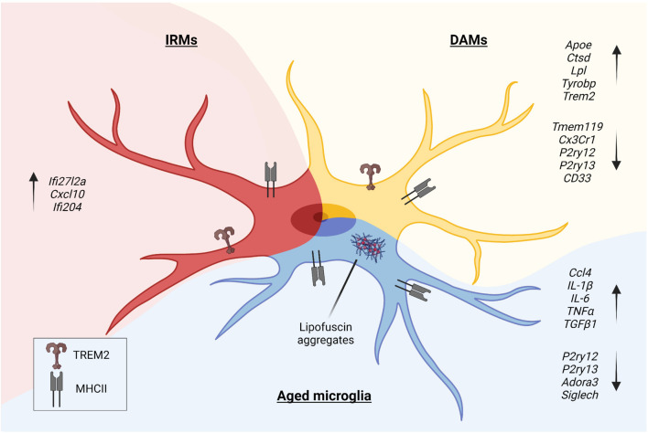
Note. Microglia experience morphologic and phenotypic/functional changes upon activation. Shown in this drawing are Disease-Associated Microglia (DAMs), Injury-Responsive Microglia (IRMs), and aged microglia, each representing a distinct activation state. Reprinted from Muzio, L., Viotti, A., & Martino, G. (2021). Microglia in Neuroinflammation and Neurodegeneration: From Understanding to Therapy. Frontiers in Neuroscience, 15, 742065. https://doi.org/10.3389/fnins.2021.742065.

Direct Activation Mechanism
One primary hypothesized mechanism involves the direct interaction of MNPs with microglia. As discussed in the previous section, NPs are believed capable of crossing the BBB and being taken up via phagocytosis. Being non-degradable, these particles persist within the microglial lysosome, which leads to a phenomenon coined “frustrated phagocytosis” (Ishida et al., 2019). The inability to clear the foreign material results in chronic lysosomal stress and damage—akin to choking themselves to death (Mularski et al., 2018). Persistent internal stress like this drives a sustained microglial activation state that remains even in the absence of a live pathogen.

Inflammasome Pathway
As a direct consequence of frustrated phagocytosis, an important inflammatory cascade is triggered: the NLRP3 Inflammasome. This complex is an intracellular receptor that senses danger signals, such as lysosomal rupture and the formation of reactive oxygen species—which are both outcomes of MP/NP internalisation. Activation of the NLRP3 inflammasome leads to the cleavage of pro-caspase-1 into active caspase-1. This activated enzyme, in turn, causes the maturation and release of pro-inflammatory cytokines, namely, Interleukin-1$β$ (IL-1$β$) and Interleukin-18 (IL-18) (Harrison, 2013; Matousek et al., 2012). These cytokines further propagate the inflammatory signal, recruiting additional immune cells and intensifying the neuroinflammatory cycle—contributing directly to neuronal injury (Delantoni et al., 2023).

Indirect Disruption via Gut-Brain Axis
Microglial activation does not require direct entry of plastic particles into the brain. Exposure in peripheral sites, particularly the gut (via ingestion) and the lungs (via inhalation), can be sufficient to drive a state of systemic inflammation. As MNPs invade and damage the intestinal and pulmonary barriers, gut bacteria and associated toxins will translocate into the bloodstream. This systemic inflammatory state results in the establishment of the GBA (Kalyan et al., 2022). As such, inflammatory signals (such as pro-inflammatory cytokines), even without crossing the BBB themselves, can signal through endothelial cells and other immune cells, or directly diffuse across the BBB, practically acting as “danger messages” that trigger an indirect, secondary activation of the quiescent microglial population and extend the peripheral damage into the CNS (Bora et al., 2024; Hoogland et al., 2015). Figure 3 demonstrates this complicated cascade, alongside the GBA.

Figure 3
Interactions Between MNPs and Human Gut
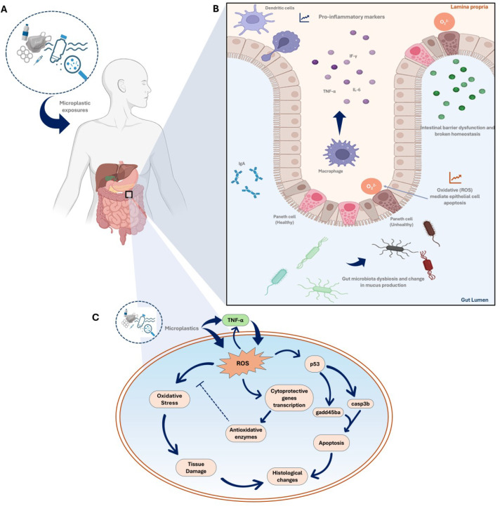
Note. Figure (A) shows the entry of MNPs into the body. Figure (B) is the inflammatory response caused by the invasion of MNPs—marked by the release of pro-inflammatory cytokines such as TNF-$α$ and IL-6. Figure (C) outlines the pathways of oxidative stress activated by MNP-induced inflammation. Reprinted from Bora, S. S., Gogoi, R., Sharma, M. R., Anshu, Borah, M. P., Deka, P., Bora, J., Naorem, R. S., Das, J., & Teli, A. B. (2024). Microplastics and human health: Unveiling the gut microbiome disruption and chronic disease risks. Frontiers in Cellular and Infection Microbiology, 14, 1492759. https://doi.org/10.3389/fcimb.2024.1492759.

Consequences and Future Directions

Observed Functional Consequences
Chronic microglial activation, sustained by MNP presence or systemic inflammatory signaling, disrupts the delicate balance required for optimal neural network function. Functionally, this has been observed in animal models to cause behavior changes—such as heightened levels of anxiety and depression-like behaviors (Chen et al., 2025; Fang et al., 2023). This also directly impairs synaptic plasticity and neurogenesis, leading to noticable performance deficits, particularly in tasks related to learning and memory (Bollinger & Wohleb, 2019; Cornell et al., 2021). These alarming outcomes suggest that MNPs contamination poses a risk to neurological health that extends beyond localized damage and impacts complex CNS functions.

HPA Axis and Stress Hormones
Another significant systemic consequence of chronic inflammation is the disruption of the hypothalamic-pituitary-adrenal (HPA) axis, often termed the Stress Axis. Pro-inflammatory cytokines released during MNP exposure, such as TNF-$α$ and IL-6, are known stimulators of the HPA axis—which lead to increased production and release of glucocorticoids, namely, cortisol (Jeon & Kim, 2016). While an initial cortial surge is protective, exposure to inflammation signals over a long time period results in HPA dysregulation—which manifests as either hyper-activation or, paradoxically, a state of hyporesponsiveness.This impaired feedback mechanism compromises the body’s ability to manage stress and inflammation effectively, becoming a debilitating cycle where chronic inflammation leads to HPA axis exhaustion, which in turn further impairs the immune system’s ability to self-regulate [Bertollo et al. (2025); (Nunez et al., 2025). This cycle can be seen in Figure 4.

Figure 4
MNP-driven HPA Axis Dysregulation Cycle
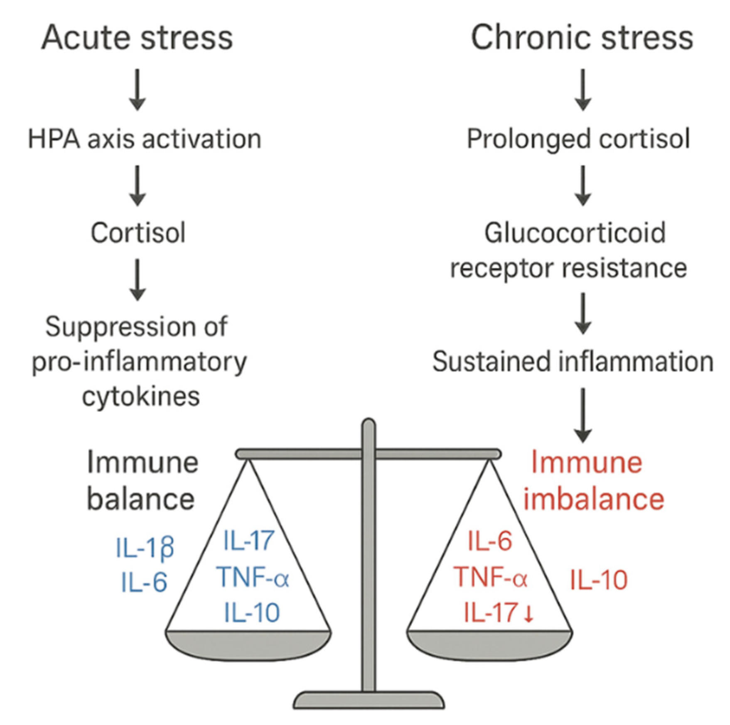
Note. The shift from a protective acute stress response (Left) to chronic endocrine and immune dysregulation (Right), a process exacerbated by sustained inflammatory signals from MNP exposure. During acute stress, the HPA axis releases Cortisol which maintains immune homeostasis by restraining pro-inflammatory cytokines (IL-1$β$, IL-6, TNF-$α$, IL-17) However, chronic MNP-induced inflammation leads to persistent HPA activation, resulting in Glucocorticoid Receptor (GR) resistance. This impaired feedback loop prevents effective immune suppression, thereby sustaining high levels of pro-inflammatory cytokines, driving chronic inflammation—and potentially autoimmunity. Reprinted from Nunez, S. G., Rabelo, S. P., Subotic, N., Caruso, J. W., & Knezevic, N. N. (2025). Chronic Stress and Autoimmunity: The Role of HPA Axis and Cortisol Dysregulation. International Journal of Molecular Sciences, 26(20), 9994. https://doi.org/10.3390/ijms26209994.

Treatment and Prevention Angle
Micro- and nanoplastic (MNP) exposure is a modern, global issue that requires an urgent, dual strategy: prevention alongside treatment. Prevention is paramount, focusing on policy changes to maximally reduce plastic production and subsequent environmental dispersal. Simultaneously, new technologies must be developed for environmentally-friendly alternatives and plastic remediation. From a biomedical standpoint, targeted treatment strategies could involve developing specific anti-inflammatory agents that target known microglial activation pathways, such as selective inhibitors of the NLRP3 Inflammasome. From a biomedical standpoint, targeted treatment strategies could involve developing specific anti-inflammatory agents that target known microglial activation pathways, such as selective inhibitors of the NLRP3 Inflammasome. Such interventions could potentially decouple inflammatory signaling from the physical presence of non-degradable particles.

Conclusion & Future Research
The evidence and analysis presented here demonstrates that MNPs are more than environmental contaminants—they are also significant neurotoxic agents, capable of long-term harm to both humans and animals alike. Their ubiquitous presence, combined with the alarming capability of nanoplastics to traverse biological barriers establishes a grave threat to CNS health. A sustained neuroinflammatory state caused by frustrated phagocytosis, NLRP3 inflammasome activation, and HPA axis dysregulation manifests as behavioral deficits and cognitive impairment. This proves that MNP exposure extends far beyond localized cellular damage.
Moving forward, a multi-disciplinary approach is crucial to translate these mechanistic findings into actionable public health strategies. Future research should work on large-scale human epidemiological studies to correlate MNP body burden with specific neurological and cognitive outcomes. There is also an urgent need for targeted therapeutic development focused on decoupling inflammatory signaling from the presence of non-degradable particles; BBB-permeable NLRP3 Inflammasome inhibitors should be a good starting point. Further mechanistic work must precisely characterize the inflammatory signals that transmit neurotoxicity from the peripheral gut to the CNS, in order to identify specific signaling molecules that trigger secondary microglial activation. Finally, to accurately reflect real-world exposure, future investigations must move beyond pristine polystyrene and prioritize the toxicity assessment of environmentally-aged and chemically-altered MNPs. While targeted biomedical interventions offer hope, the most effective long-term solution is proactive, globally-coordinated prevention to dramatically reduce plastic production and environmental dissemination.

Abbreviations
Abbreviation | Full Term
BBB | Blood-Brain Barrier
CNS | Central Nervous System
GBA | Gut-Brain-Axis
GR | Glucocorticoid Receptor
HPA | Hypothalamic-Pituitary-Adrenal
IL-1$β$ | Interleukin-1$β$
IL-6 | Interleukin-6
IL-18 | Interleukin-18
MNPs | Micro- and Nanoplastics
MPs | Microplastics
NPs | Nanoplastics
ROS | Reactive Oxygen Species
TNF-$α$ | Tumor Necrosis Factor-$α$

References
Bertollo, A. G., Santos, C. F., Bagatini, M. D., & Ignácio, Z. M. (2025). Hypothalamus-pituitary-adrenal and gut-brain axes in biological interaction pathway of the depression. Frontiers in Neuroscience, 19. https://doi.org/10.3389/fnins.2025.1541075
Bollinger, J. L., & Wohleb, E. S. (2019). The formative role of microglia in stress-induced synaptic deficits and associated behavioral consequences. Neuroscience Letters, 711, 134369. https://doi.org/10.1016/j.neulet.2019.134369
Bora, S. S., Gogoi, R., Sharma, M. R., Anshu, Borah, M. P., Deka, P., Bora, J., Naorem, R. S., Das, J., & Teli, A. B. (2024). Microplastics and human health: Unveiling the gut microbiome disruption and chronic disease risks. Frontiers in Cellular and Infection Microbiology, 14, 1492759. https://doi.org/10.3389/fcimb.2024.1492759
Campbell, C. S. J., Contreras-Rojas, L. R., Delgado-Charro, M. B., & Guy, R. H. (2012). Objective assessment of nanoparticle disposition in mammalian skin after topical exposure. Journal of Controlled Release, 162(1), 201–207. https://doi.org/10.1016/j.jconrel.2012.06.024
Chen, L., Zeng, L., Li, W., & Li, J.-S. (2025). The Activation of Hippocampal Microglial Cells and Their Role in the Regulation of Pain. Journal of Integrative Neuroscience, 24(6), 27730. https://doi.org/10.31083/jin27730
Cheng, S., Ye, Z., Wang, X., Lian, C., Shang, Y., & Liu, H. (2023). The effects of adsorbed benzo(a)pyrene on dynamic behavior of polystyrene nanoplastics through phospholipid membrane: A molecular simulation study. Colloids and Surfaces B: Biointerfaces, 224, 113211. https://doi.org/10.1016/j.colsurfb.2023.113211
Cornell, J., Salinas, S., Huang, H.-Y., & Zhou, M. (2021). Microglia regulation of synaptic plasticity and learning and memory. Neural Regeneration Research, 17(4), 705–716. https://doi.org/10.4103/1673-5374.322423
Delantoni, A., Sarafopoulos, A., Giannouli, N., & Rafailidis, V. (2023). Maxillofacial inflammations visualized with ultrasonography. Description of the imaging features and literature review based on a characteristic case series. Journal of Ultrasonography, 23(93), e80–e89. https://doi.org/10.15557/jou.2023.0015
Fang, S., Wu, Z., Guo, Y., Zhu, W., Wan, C., Yuan, N., Chen, J., Hao, W., Mo, X., Guo, X., Fan, L., Li, X., & Chen, J. (2023). Roles of microglia in adult hippocampal neurogenesis in depression and their therapeutics. Frontiers in Immunology, 14. https://doi.org/10.3389/fimmu.2023.1193053
Hamed, M., Martyniuk, C. J., Naguib, M., Lee, J.-S., & Sayed, A. E.-D. H. (2022). Neurotoxic effects of different sizes of plastics (nano, micro, and macro) on juvenile common carp (Cyprinus carpio). Frontiers in Molecular Neuroscience, 15. https://doi.org/10.3389/fnmol.2022.1028364
Harrison, C. (2013). Chiasma and Roche partner in oral peptide drug delivery. Nature Reviews Drug Discovery, 12(4), 255–255. https://doi.org/10.1038/nrd3989
Hoogland, I. C. M., Houbolt, C., van Westerloo, D. J., van Gool, W. A., & van de Beek, D. (2015). Systemic inflammation and microglial activation: Systematic review of animal experiments. Journal of Neuroinflammation, 12, 114. https://doi.org/10.1186/s12974-015-0332-6
Ishida, T., Fujihara, N., Nishimura, T., Funabashi, H., Hirota, R., Ikeda, T., & Kuroda, A. (2019). Live-cell imaging of macrophage phagocytosis of asbestos fibers under fluorescence microscopy. Genes and Environment, 41, 14. https://doi.org/10.1186/s41021-019-0129-4
Jeon, S. W., & Kim, Y. K. (2016). Neuroinflammation and cytokine abnormality in major depression: Cause or consequence in that illness? World Journal of Psychiatry, 6(3), 283–293. https://doi.org/10.5498/wjp.v6.i3.283
Kalyan, M., Tousif, A. H., Sonali, S., Vichitra, C., Sunanda, T., Praveenraj, S. S., Ray, B., Gorantla, V. R., Rungratanawanich, W., Mahalakshmi, A. M., Qoronfleh, M. W., Monaghan, T. M., Song, B.-J., Essa, M. M., & Chidambaram, S. B. (2022). Role of Endogenous Lipopolysaccharides in Neurological Disorders. Cells, 11(24), 4038. https://doi.org/10.3390/cells11244038
Kopatz, V., Wen, K., Kovács, T., Keimowitz, A. S., Pichler, V., Widder, J., Vethaak, A. D., Hollóczki, O., & Kenner, L. (2023). Micro- and Nanoplastics Breach the Blood–Brain Barrier (BBB): Biomolecular Corona’s Role Revealed. Nanomaterials, 13(8), 1404. https://doi.org/10.3390/nano13081404
Li, X., Hu, S., Yu, Z., He, F., Zhao, X., & Liu, R. (2025). New Evidence for the Mechanisms of Nanoplastics Amplifying Cadmium Cytotoxicity: Trojan Horse Effect, Inflammatory Response, and Calcium Imbalance. Environmental Science & Technology, 59(19), 9471–9485. https://doi.org/10.1021/acs.est.5c01254
Matousek, S. B., Ghosh, S., Shaftel, S. S., Kyrkanides, S., Olschowka, J. A., & O’Banion, M. K. (2012). Chronic IL-1β-mediated neuroinflammation mitigates amyloid pathology in a mouse model of Alzheimer’s disease without inducing overt neurodegeneration. Journal of Neuroimmune Pharmacology, 7(1), 156–164. https://doi.org/10.1007/s11481-011-9331-2
McConnell, H. L., & Mishra, A. (2022). Cells of the Blood-brain Barrier: An Overview of the Neurovascular Unit in Health and Disease. Methods in Molecular Biology (Clifton, N.J.), 2492, 3–24. https://doi.org/10.1007/978-1-0716-2289-6_1
Mularski, A., Marie-Anaïs, F., Mazzolini, J., & Niedergang, F. (2018). Observing Frustrated Phagocytosis and Phagosome Formation and Closure Using Total Internal Reflection Fluorescence Microscopy (TIRFM). Methods in Molecular Biology (Clifton, N.J.), 1784, 165–175. https://doi.org/10.1007/978-1-4939-7837-3_16
Muzio, L., Viotti, A., & Martino, G. (2021). Microglia in Neuroinflammation and Neurodegeneration: From Understanding to Therapy. Frontiers in Neuroscience, 15, 742065. https://doi.org/10.3389/fnins.2021.742065
Nunez, S. G., Rabelo, S. P., Subotic, N., Caruso, J. W., & Knezevic, N. N. (2025). Chronic Stress and Autoimmunity: The Role of HPA Axis and Cortisol Dysregulation. International Journal of Molecular Sciences, 26(20), 9994. https://doi.org/10.3390/ijms26209994
Thompson, R. C., Olsen, Y., Mitchell, R. P., Davis, A., Rowland, S. J., John, A. W. G., McGonigle, D., & Russell, A. E. (2004). Lost at Sea: Where Is All the Plastic? Science, 304(5672), 838–838. https://doi.org/10.1126/science.1094559
Wake, H., Moorhouse, A. J., & Nabekura, J. (2011). Functions of microglia in the central nervous system – beyond the immune response. Neuron Glia Biology, 7(1), 47–53. https://doi.org/10.1017/S1740925X12000063
Winiarska, E., Jutel, M., & Zemelka-Wiacek, M. (2024). The potential impact of nano- and microplastics on human health: Understanding human health risks. Environmental Research, 251, 118535. https://doi.org/10.1016/j.envres.2024.118535
Yan, L., Yu, Z., Lin, P., Qiu, S., He, L., Wu, Z., Ma, L., Gu, Y., He, L., Dai, Z., Zhou, C., Hong, P., & Li, C. (2023). Polystyrene nanoplastics promote the apoptosis in Caco-2 cells induced by okadaic acid more than microplastics. Ecotoxicology and Environmental Safety, 249, 114375. https://doi.org/10.1016/j.ecoenv.2022.114375
Yang, I., Han, S. J., Kaur, G., Crane, C., & Parsa, A. T. (2010). The Role of Microglia in Central Nervous System Immunity and Glioma Immunology. Journal of Clinical Neuroscience : Official Journal of the Neurosurgical Society of Australasia, 17(1), 6–10. https://doi.org/10.1016/j.jocn.2009.05.006

